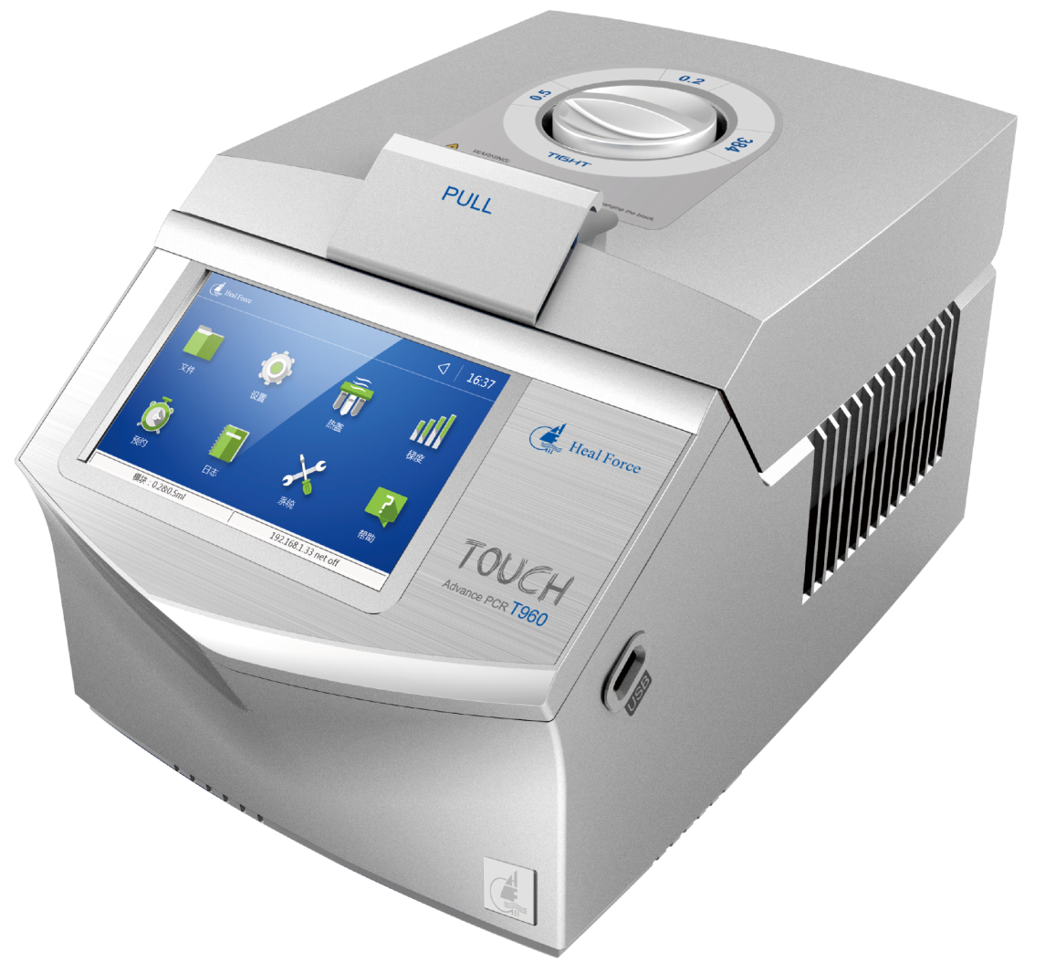
Heal Force Thermal Cycler
PCR platform you can depend on

For over 10 years we have specialized in thermal cyclers with proven performance and unmatched combination of features, just right for every laboratory, whether you run only a few samples per week or perform high-through processes
Thousands of our products are in daily use around the globe, helping scientism health professionals and laboratory managers achieve high levels of accuracy and consistency in their work
Our dedication to PCR is a guarantee that we will continue to provide best solutions with the best services for many years to come
We believe in giving our customers a choice in how they use our thermal cyclers, supported by excellent service and support. We aim to deliver value for our customers who partner with us and we believe that respectability is the keystone for all our business activities

A trusted brand
delivering your choice
2003
The Thermal Cycler manufacturer center was established in Hangzhou, in the same year we cooperated with other innovative Gene companies, and developed the first real-time PCR detection system which was put into mass production
2005
Membrane liquid-based cell production machine, and 32 well PCR Thermal Cycler(K320)were successfully developed and put into production

Wecome to Heal Force

Wecome to Heal Force
Global coverage,
service and support

2007
Launched 64-well PCR Thermal Cycler
2009
The gradient Thermal Cycler K960 was successfully developed and put into production
2010
Completed the research and development of the smart gradient Thermal Cycler B960, and put into production
2012
Launched an intelligent gradient Thermal Cycler with large color touch screen
2015
A brand new generation of real-time PCR...
Right Solution, First Time
combine the information about your applications- sequencing, cloning, genotying, mutagenesis, ect, lab design
and budget to ensure you get the night solution for your particular need

Every Heal Force solution comes complete with one extra feature- first class service and support wherever you are in the world. Our service engineers apply their expertise to guide installation, validation and maintenance of your PCR thermal cycler solution in compliance with all the relevant codes
Delivering Service Excellence
First-time-fix and customized service contracts to suit
budgets and demand
Training
Hands on operation training(on or off site)to get you
up and running first time

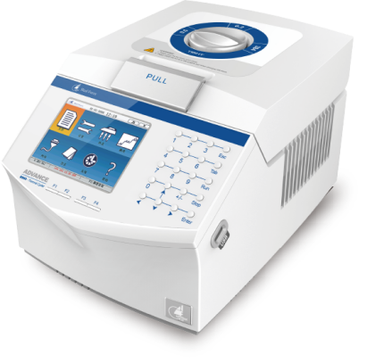
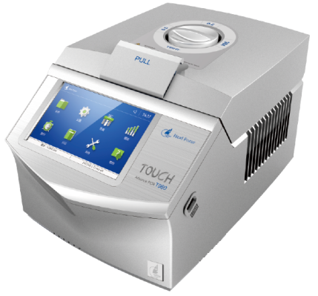
Model | T960 | B960 | K960 | KF960 | K640 | K160
Block Formats | 96x02m(A)、54×0.5m(B)、96×0.2m+770.5m(C)、384well(D） |  |  |  | 64x0.2ml(A)  36x0.5ml(B) | 30x0.2ml(A) 9x0.5ml(B)  16×0.2+9×0.5ml(C)
Temp Range | 0℃-999℃ | 0℃-999℃ | 0℃-999℃ | 0℃-999℃ | 4℃-999℃ | 0℃-999℃
Display Interface | 7 LCD | 5.7 LCD | 5.7 LCD | 5.7 LCD | 4.3 LCD | 12864 LCD
Max Heating Ramp Rate | 5.0℃/s | 4.5℃/s | 4.0℃/s | 4.0℃/s | 2.5℃/s | 2.0℃/s
Max Cooling Ramp Rate | 5.0℃/s | 4.0℃/s | 3.5℃/s | 3.5℃/s | 2.5℃/s | 2.0℃/s
Heating/oooling adjustable rate | 0.1℃/s/s-4.0℃/s | 0.1℃/s/s-4.0℃/s | 0.1℃/s/s-4.0℃/s | 0.1℃/s/s-4.0℃/s | - | -
Uniformity | ≤±0.2℃ | ≤±0.2℃ | ≤±0.2℃（20-75） | ≤±0.2℃（20-75） | - | ≤±0.3℃（20-75）
Accuracy | ≤±0.1℃ | ≤±0.1℃ | ≤±0.2℃ | ≤±0.2℃ | ≤±0.2℃ | ≤±0.2℃
Gradient Temp Range | 30-99℃ | 30-99℃ | 30-99℃ | - | - | -
Thermal Gradient Span | 1-30℃ | 1-30℃ | 2-30℃ | - | - | -
Gradient Uniformity | ≤±0.2℃(single row) | ≤±0.2℃(single row) | ≤±0.2℃(single row) | - | - | -
Hot Lid Temp | 20-110℃ | 20-110℃ | 30-115℃ | 30-115℃ | - | -
Temp Control Mode | Block、tube* | Block、tube* | Block、tube | Block、tube | Block | Block
Memory Capacity | 2000* | 1000* | 200 | 200 | 9 | 3
Max No of Cycle | 999 | 999 | 99 | 99 | 99 | 99
Communication | USB2.0/RS 232/RJ45 | USB2.0/RS 232/RJ45 | USB2.0/RS 232 | USB2.0/RS 232 | - | Serial port
Intelligent Diagnosis | 108 | 108 | - | - | - | -
Size(WxDXH, mm) | 380×270×250 | 380×270×250 | 380×270×250 | 380×270×250 | 370×260×290 | 160×140×120
Weight(kg) | 8.1 | 7.8 | 7.2 | 7.2 | 4.9 | 2.2
* 10-100ul Optional
** Unlimited with use of USB memory stick
Solutions finder
This guide will help you select the best solution for your application needs. Our team of technical/application specialists are available to answer questions，as well as provide friendly，expert advice.export@healforce.com
Heal force Thermal Cyclers
Your Choice

T960/B960/K960/KF960 Reaction Modules for PCR
96-well Reaction Module, Gradient Enabled* Holds 96x0.2ml tubes or one 96-well plate
54-well Reaction Module. Gradient Enabled* Holds 54×0.5ml tubes
96-well+77-well Reaction Module, Gradient Enabled* Holds 96x0.2ml tubes, one 96-well plate or 77x0.5ml tubes
384-well Reaction Module Holds one 384-well plate
K640 Reaction Modules for PCR
64-well Reaction Module Holds 64×0.2 ml tubes
36-well Reaction Module Holds36×0.5 ml tubes
K160 Reaction Modules for PCR
30-well Reaction Module Holds 30x0.2ml tubes
9-well Reaction Module Holds 9x0.5ml tubes
16-well +9-well Reaction Module Holds 16x0.2ml tubes or 9x0.5ml tubes
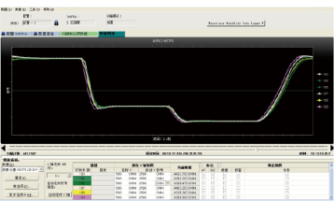
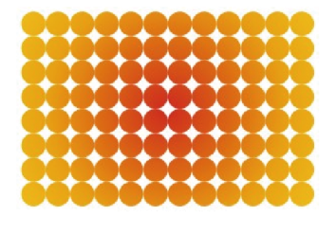
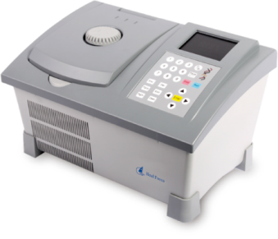
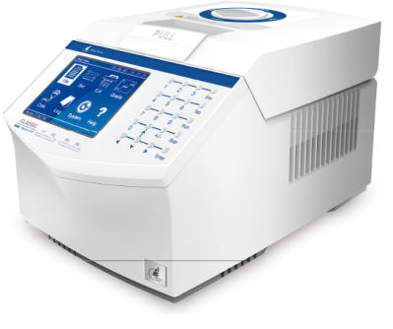
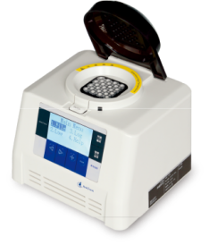
Gradient function is not applicable to KF960
Flexible and interchangeable sample blocks
Since PCR is central to genomics research, you need a flexible platform that can adapt as your research evolves
Heal Force thermal cyclers' modular design gives you a whole new level of versatility. Easy-to-change sample blocks in variety of well formats and materials let you configure a system for a wide range of PCR and cycle sequencing methods- today and tomorrow.

Conventional temperature diagram

Gradient temperature diagram

Superior uniformity with rapid arrival at target temperature

Outstanding thermal performance and superior uniformity
If you are like most researchers, you want to get results faster. A key components of overall protocol run time is the time to reach target temperature, which is determined by the average ramp rate and the time for the sample block to reach thermal uniformity. Heal Force thermal cyclers sample blocks with unique design and treatment heat and cool more quickly to target temperature than standard blocks, so average ramp rates are increased and overall run times are reduced
In PCR, precise and accurate block control is paramount. Heal Force thermal cyclers have six independently
controlled thermal electric modules(TEs)", the heating and cooling elements of the thermal cycler, to maintain tight temperature uniformity at all points during a run-even during ramping. Precise, uniform heating and cooling assures superior reproducibility and highest quality results
Applicable for T960/B960/K960/KF960

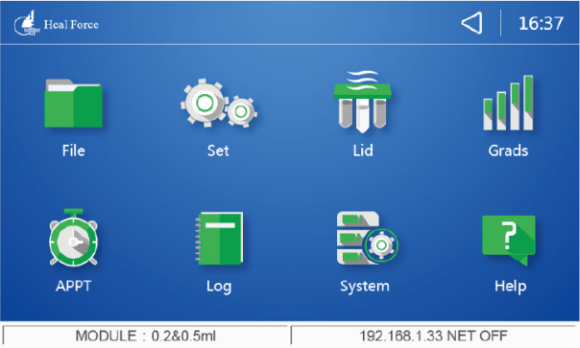
Remote Management System
T960 Intuitive Touch Screen
Genemate T960’s advanced
technology highlight
Overview
The Genemate T960 Touch cycler is the flagship of Heal Force thermal cycling platform, offering unmatched
performance for fast, accurate results and a state-of-the art interface with new ways to optimize protocols and
meet any researcher's unique needs. Choose from multiple interchangeable reaction modules, Use the intuitive
touch screen interface, Optimize PCR assays using the gradient feature, Transport your files and data with USB flash drive, Connected to your lab top/PC for remote monitoring and future upgrading. What else do you need from a PCR cycler?
Intuitever touch screen makes running PCR easie than before!
The powerful, yet simple-to-operate user interface on the T960 system is driven by the 7-inch colorful touch screen. The large and intuitive graphical screen allows for real-time viewing of your temperature profiles Additionally, the large navigation buttons put programming of the T960 Thermal Cycler at your fingertips. Set-up and navigation do not require
the use of a stylus or mouse

Realization of intelligence!
Adopt the windows CE operating system to ensure the realization of intelligent instrument, with more than 100 self-diagnostic functions T960 achieves the network connection independently, users can visit our official website to update version, which prevent the complex operations and inconvenience of the traditional program updating

Remote Management System from anywhere and everywhere!
Access your T960 Thermal Cyclers everywhere you go with
optional Remote Management Software, which allows you to
manage and monitor over 200 thermal cyclers from your computer.
Create and edit methods on your computer and download from or
upload to your Thermal Cyclers systems as needed. The power of
the T960 Thermal Cycler is just a click away

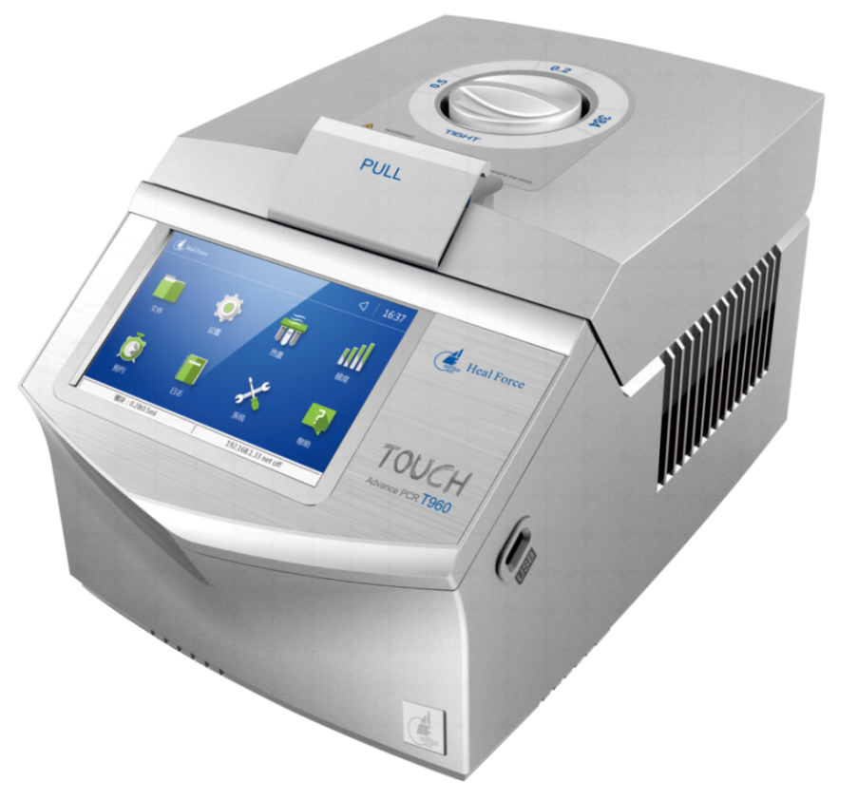
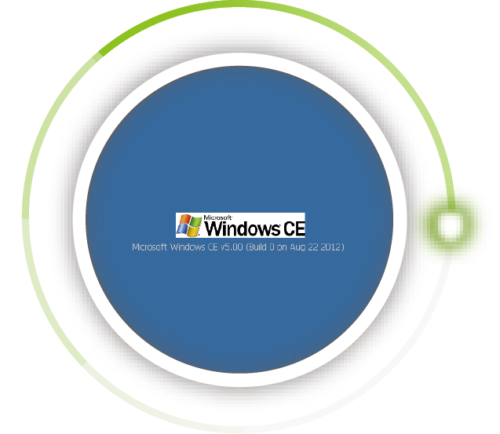
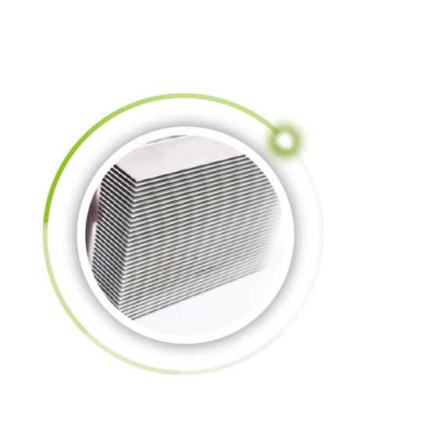
Environment& user friendly
-Optimized to very low energy consumption
-With its ultra-quiet ventilation, low noise levels are achieved, Enjoy it!
Simple data transfer
-Portability: Transfer methods between generate systems via USB Ports
-Backup: Store your most Important methods on a USB memory stick
-Storage: Store an unlimited number of methods by using a USB memory stick
-Uploads: Update firmware when enhancements become available
Powerful heart and memory
-Optimized to very low energy consumption
-With its ultra-quiet ventilation, low noise levels are achieved, Enjoy it!
Patented portable design for blocks
-Versatile configuration options
-Gold/Silver coated blocks increase heat
conduction efficiency
-Portable design is easy for sample blocks
interchange without maintenance

Large colorful touch screen display
-7 inches full color display with touch screen z operation
-Intuitive graphical programming
-Make a reservation and alarm for daily lab we
-Support the function of TM value calculation
Reliable lids
-Specially designed lids reduce the evaporation during PCR
-Hinge utilized in lab top industry makes lid open more flexible
-Knob helps to accommodate a wide variety of PCR consumables

B960
Smart Gradient Thermal Cycle
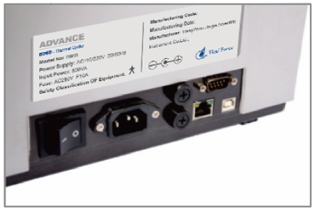
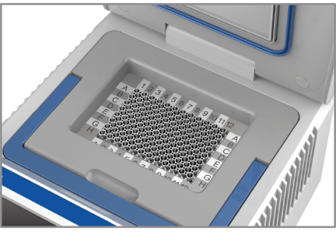
Communication Ports
Interchangeable Blocks
Adjustable Hot Lid
Reliable guarantee for the accuracy of the temperature
Temperature extended control mode which is closer to required experiment temperature control and is
able to effectively avoid the system error caused by the dis accord of the temperature points
among the instrument's display temperature, actual block temperature and the temperature
equired for reagents So as to improve the accuracy of the experiment and ensure
the high efficiency, Strict temperature control debugging program makes sure
that each instrument can meet the needs of different experiments
12 channel temperature probes detect simultaneously, which ensure the
homogeneity of sample temperature. The hermetic-space technique
can efficiently eliminate PCR marginal effect. The technique of
outside temperature probe tracing the inside curve testing can
effectively ensure the accuracy of sample temperature

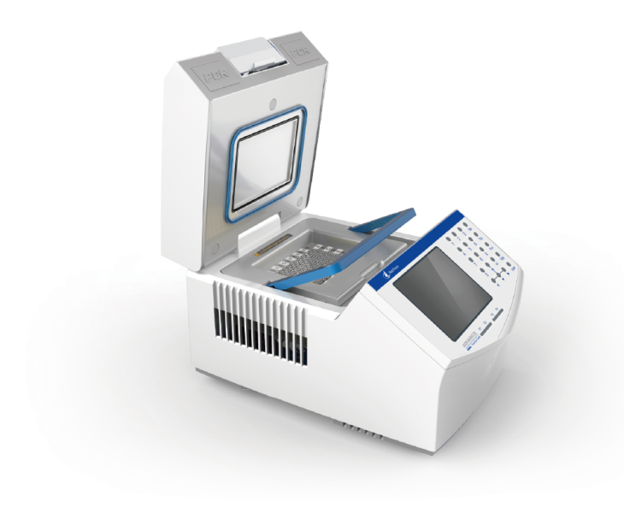
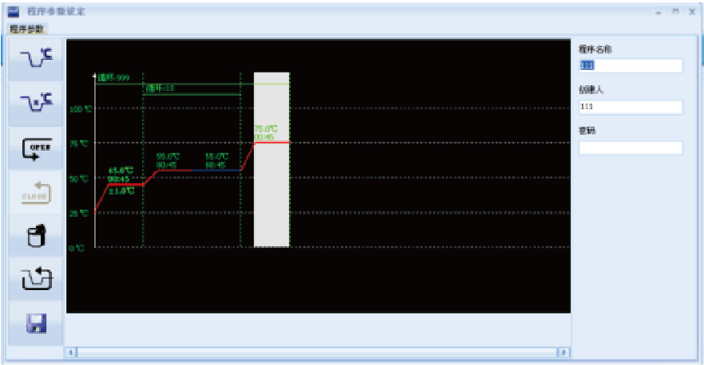
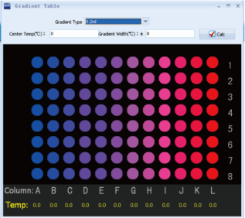
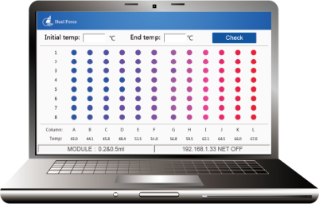
Features
Convenient and flexible module change
hermetic seal protects blocks from consendation, maximizing their life
Two-stage hot lid pressure regulator, endures good sealing performance
Gold-plated or silver-plated module improves the efficiency of heat conduction
arge size and color super-high-definition LCD screen
Intuitive and user-friendly interface, makes programming quick and easy
Infinitely adjustable lid knob, suitable for various types of tubes
Memory function in case of power-down.
Low noise, low energy consumption, long service life
Heat lid could be positioned at any angle for easy sample access
Metal material lid. more reliable and safe
Hard disk and mouse can be linked
Linked with PC for its multiple control
Windows operating system
Convenient, free-charge program upgraded
Remote diagonsis system for easy maintenance
Achieve circulation nesting
110-220V international general voltage
Gradient Calculator by PC Software
Protocol set by PC Software
Remote Management System
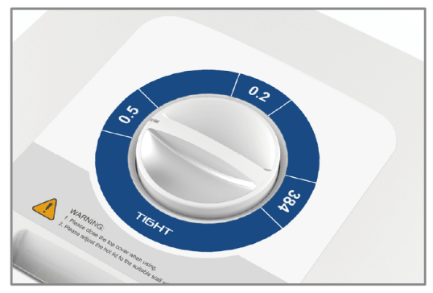
z
Hermetic Seal Protects Blocks from Condensation
Adjustable Hot Lid
Interchangeable Blocks
The most advanced semiconductor technology(Peltier based)
No matter how you configure your K960 gradient thermal cycler system,
it provides the high-end performance you need, easily adapts to meet
Your labs changing PCR needs, and helps you stay within your
budget. Designed for trouble-free, long-life operation even in the
most rigorous environments the K960 delivers outstanding
Reproduction-well-to-well sample-to-sample,
and instrument-to-instrument
K960
Gradient Thermal Cycle
Technical parameters
Model | K960-A;K960B;K960-C;K960D
Capacity | 96x0.2mL(A);54×0.5mL(B)  96x0.2mL+770.5ml(C);384well(D)
Temp range | 0℃~99.9℃(Rt≤30℃)
Max cooling rate | ≥3.5℃/s
Max heating rate | ≥4.0℃/s
Heating/cooling rate | 1℃/s-4 ℃/s(Adjustable)
Uniformity | ≤±0.2℃(20-75℃),  ≤±0.3℃(95℃)
Accuracy | ≤±0.2℃
Gradient temp range | 30℃~99℃
Gradient spread | 2℃~30℃
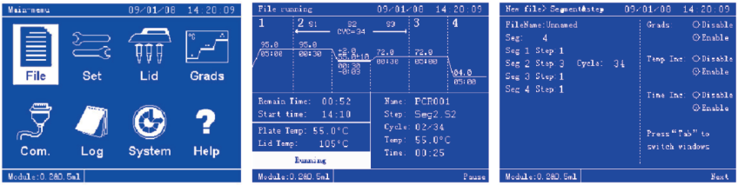
Product features
Convenient and flexible module replacement mo dual
Large size super-high-definition LCD screen
Intuitive, user-friendly interface makes program easier and faster
Memory function in case of power-down
Low noise, low energy consumption, long service life
Solemn, elegant appearance, innovative design
Adjustable hot lid prevents reagents form evaporating
Optimal panel keypad design for convenient operation
Heated lid could be positioned at any angle
Handle-module, more secure and convenient for module replacement,
improving interchanging efficiency and long life span

Instrument working conditions:
Ambient temperature: 5C-30C
Relative humidity <90%
Power supply:AC110V±22V,220V±22V250VA,50Hz±10Hz
Instrument storage conditions
Ambient temperature -20 C
Relative humidity: <90%
Gradient uniformity | ≤0.2℃
Heated lid temp | 30℃~115℃
Environment model | Manual select
Temp control | Block，tube, calculated
Stored program No | 200
Max.No. Of Cycle | 99
Display | 5.7inch, 320x240pels LCD
Communication | USB2.0/ Rs232
Size | 380mm(W)x270mm(D)x250mm(H）
Weight | 7.2kg
Power supply | 110V-220V international general voltage

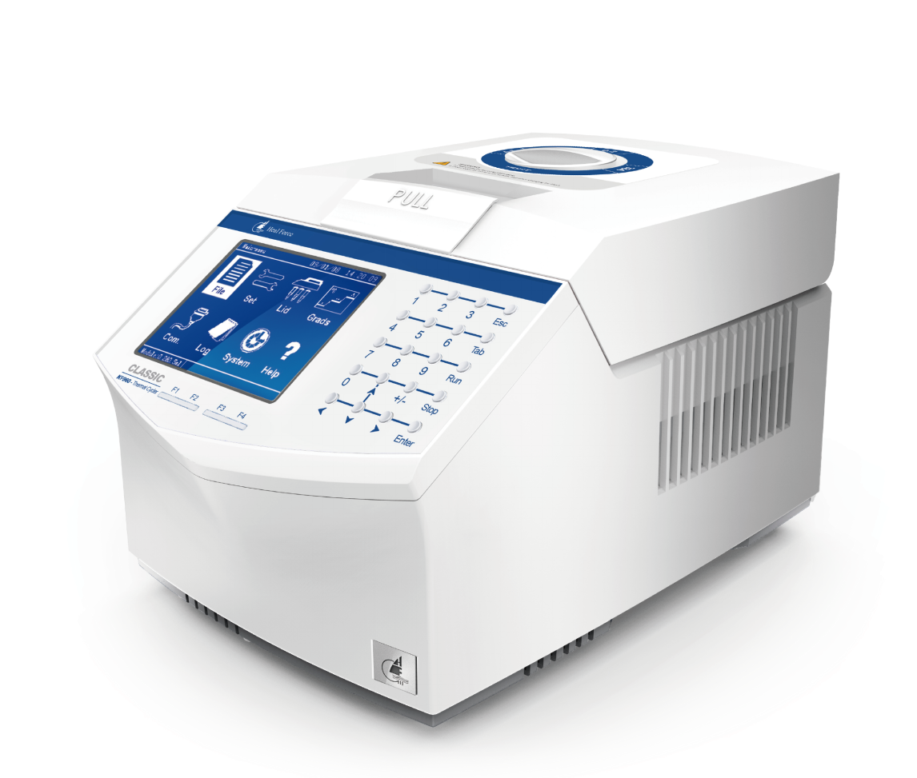
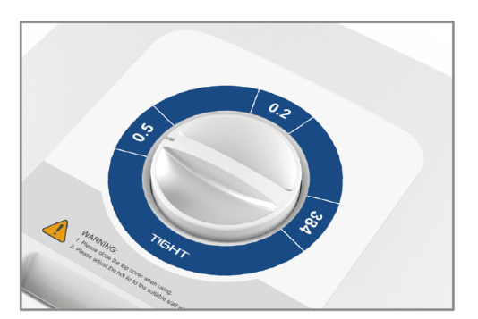
Adjustable Hot Lid
Hermetic Seal Protects Blocks from Condensation

Interchangeable Blocks

Overview
Do not let poor instruments compromise your PCR results. Take control of your experiments! Heal Force KF960 thermal cycling system gives you the power to do the experiments you want to do, the way you want to do them. All that experience—millions of reactions a day一adds up to confidence, whether you're doing a few samples, or a few thousand. KF960 supports your constant strive for exceptional uniformity and meaningful results
KF960
Thermal Cycler
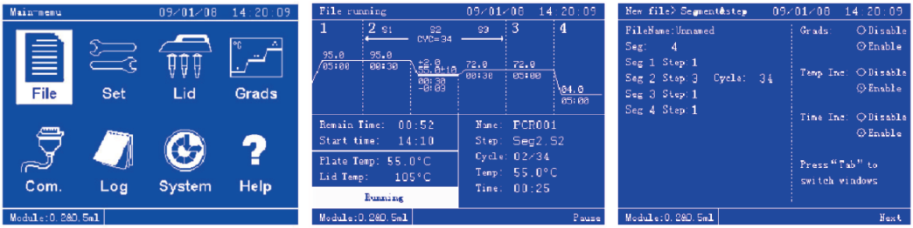
Technical parameters
Model | KF960-A; KF960-B; KF960-C; KF960-D
Capacity | 96x0.2mL(A); 54x0.5mL(B); 96x0.2mL+77x0.5ml (C); 384well (D)
Temp range | 0℃~99.9℃ (Rt≤30℃)
Max cooling rate | ≥3.5℃/s
Max heating rate | ≥4℃/s
Heating/cooling rate | 1℃/s~4℃/s（Adjustable）
Uniformity | ≤士0.2℃(20-75℃)
Accuracy | ≤士0.2℃

Heated lid temp | 30℃~115℃
Environment model | Manually select
Temp control | block, tube, calculated
Stored program No. | 200
Max. No. of Cycle | 99
Display | 5.7inch, 320x240pels LCD
Communication | USB2.0, RS232
Size | 380mm(W)x270mm(D)x250mm(H)
Weight | 7.2kg

Product features
Convenient and flexible module replacement mode
Large size super-high-definition LCD screen
Intuitive, friendly user interface makes program easier and faster
Memory function in case of power-down
Low noise, low energy consumption, long application life
Solemn, elegant appearance, innovative model
Unique rotating stall heat-regulating function
Optimal panel design for more convenient operation
Heated lid could be stopped at any angle
Handle-module, more secure and convenient module replacement, improving using efficiency and expanding using years
Instrument working conditions:
Ambient temperature: 5 C-30 C
Relative humidity: < 90 %
Power supply: AC110V土22V, 220V士22V,250VA,50Hz士10Hz

Instrument storage conditions:
Ambient temperature: -20·c-55'C
Relative humidity: < 90%
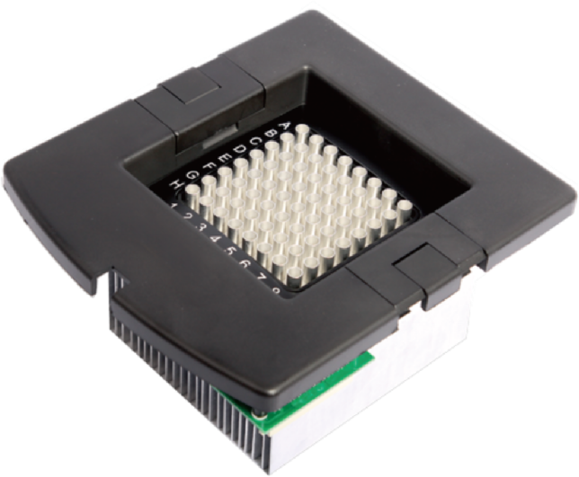
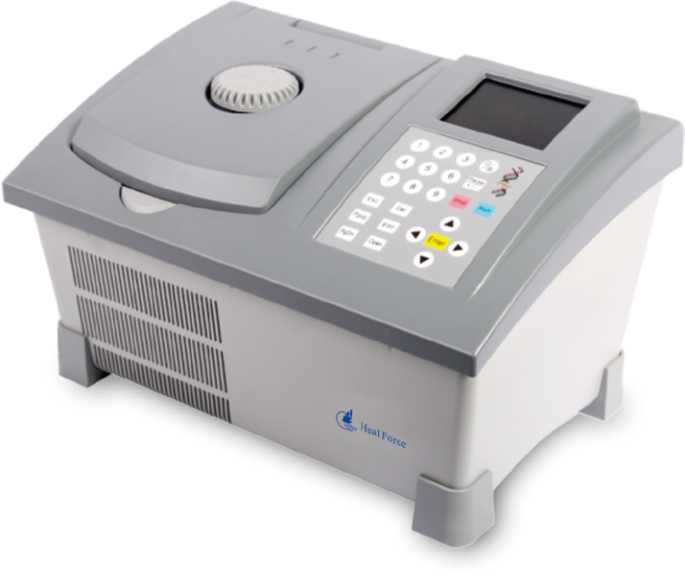
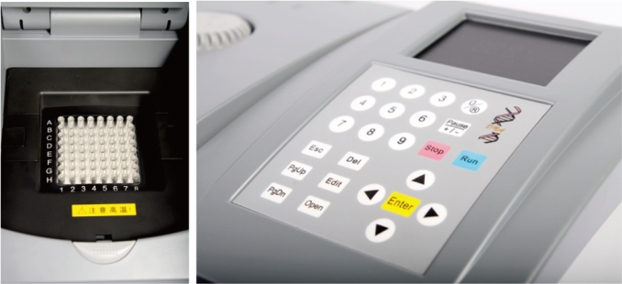
Technical parameters
Capacity | 64x0.2mL; 36x0.5mL
Temp range | 4℃~99.9℃
Max cooling rate | 2.5℃/s
Max heating rate | 2.5℃/s
Temp display accuracy | 0.1℃
Accuracy | ≤士0.2℃
Temp fluctuation | ≤士0.1℃
Uniformity | ≤士0.3℃(20~72℃), ≤士0.5℃(95℃)
Max program unit | 9
Max cycle steps | 9
Max cycle No. | 99
Max constant temperature time | 50m59s
Max constant temperature | preservation time 99h59m
Stored program No. | 100
Size | 370mm(W)x250mm(D)x230mm(H)
Weight | 5kg

Product features
Adjustable pressure hot lid, to prevent volatilizing and dewing
Hot lid with pressure alarm device, to prevent damaging test tube from too much pressure.
Convenient and flexible module replacement mode.
Innovative module wire socket design achieves module replacement without wire
The unique separate design of amplification and operating area makes users safer and more convenient
K640
Thermal Cycler
Technical parameters
Capacity | 30x0.2mL(A); 9x0.5mL(B); 16x0.2mL+9x0.5mL(C)
Temp range | 0℃~99.9℃(Rts30℃)
Max cooling rate | ≥2℃/s
Max heating rate | ≥2℃/s
Uniformity | ≤士0.3℃ (constant 10s)
Accuracy | ≤士0.2℃
Temp control | Block
Stored program No. | 3
Max. No. of Cycle | 99
Display | 12864LCD
Communication | serial port
Size | 160mm(W)x140mm(D)x120mm(H)
Weight | 2.2kg
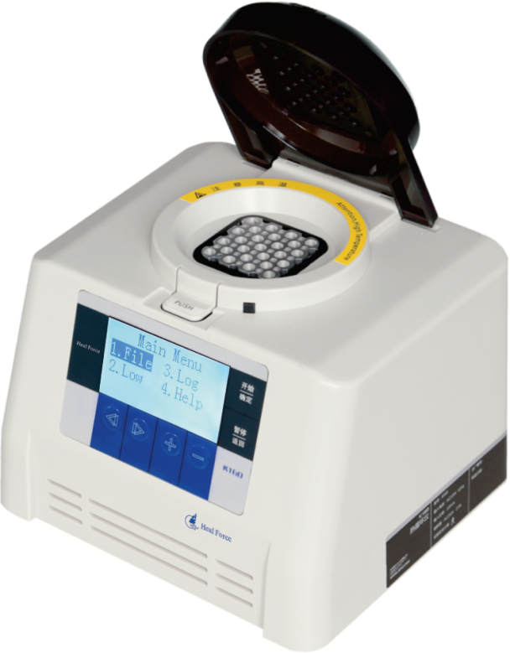
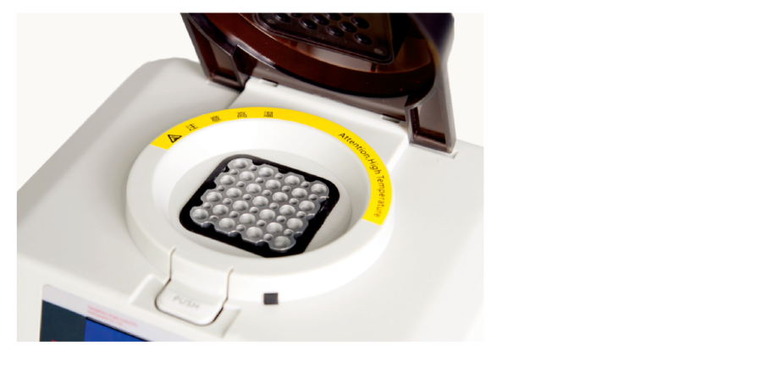
Optional instruments

Product features
It is small-sized and easy to program with an intuitive user
interface
The lid adopts the high temperature resistant material and
applicable to various types of test tube
Memory function in case of power-down
Two control modes: PCR control through the PC operating
software
It helps students understand PCR process with animated
presentation through PC software
Achieve circulation nesting
K160
Mini-PCR
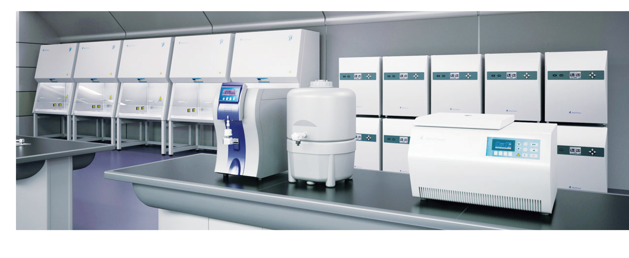
Biosafety Cabinet
Heal Force brand stands for the highest standards of safety, ergonomics and performance. Taking advantage of a heritage from over 25 years experience, Heal Force offers safety features, options and accessories beyond the standard requirements, to fulfill virtually all needs. Thousands of units installed in laboratories in more than 100 Countries.
Centrifuge
Neofuge, the name that defines quality centrifuges from Heal Force. Offering bench-top high speed models with or without refrigeration for today's discerning laboratory technicians. Neofuge series provide excellent centrifugal effect and maximum application versatility.
CO2/Tri-Gas Incubator
Heal Force Smart Cell incubator provides you with unsurpassed natural simulation to ensure optimum growth conditions for you culture at all time. That's why it becomes the first choice of researchers in fields of application including tissue engineering, in vitro fertilization, neuroscience, cancer research and other mammalian cell researches.
CO2/Tri-Gas Incubator
Heal Force Smart Cell incubator provides you with unsurpassed natural simulation to ensure optimum growth conditions for you culture at all time. That's why it becomes the first choice of researchers in fields of application including tissue engineering, in vitro fertilization, neuroscience, cancer research and other mammalian cell researches.
Water Purification
Well-proved Heal Force water purification system offers ideal and comprehensive solution for a choice of water qualities that range from primary for simple routine washing and rinsing, through to ultra-high grade for the most critical science and analytical applications.
Thermal Cycler
Since PCR is central for molecular biology research, you need flexible solutions that can help you achieve PCR success for virtually any application. Heal Force has been developing new cycling platforms from economical option to advanced series to empower your search. These instruments are renowned for their reliability, accuracy, and user-friendly interfaces.

Heal Force specialises in the design, development, manufacture and sales of laboratory equipments in the fields of Bio safety protection, Centrifugation, Cell culture, Water purification & Gene amplification.
Heal Force Laboratory Equipment

