Heal Force Laboratory Equipment
Heal Force specialises in the design, development, manufacture and sales of laboratory equipments in the fields of Biosafety protection, Centrifugation, Cell culture, Water purification & Gene amplification.
Life Science ，Heal Force
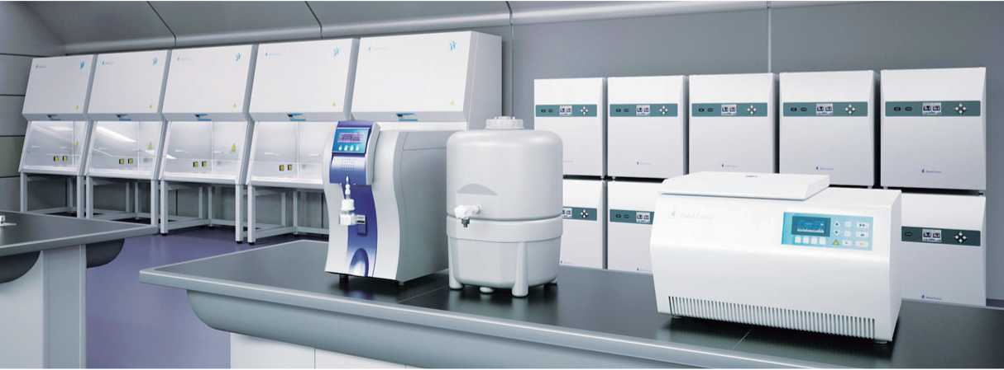
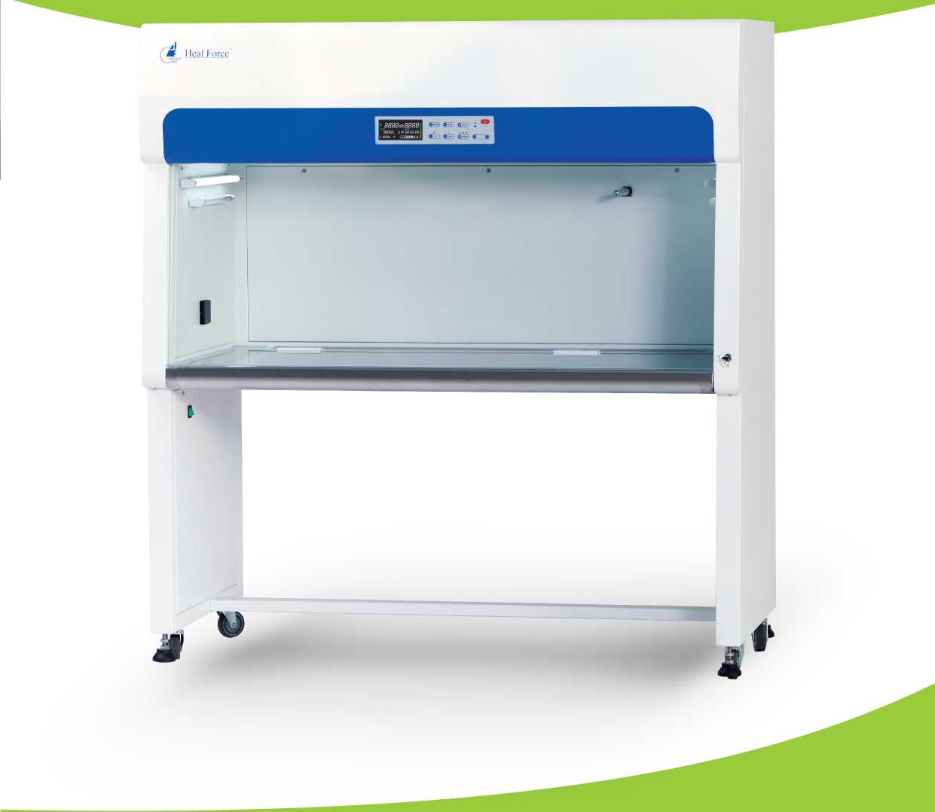
AlphaClean 1300
Vertical Laminar Flow Clean Benches
Heal Force Bio-Meditech Holdings Group, Nison instrument (Shanghai) Limited 6788 Songze Road,Qingpu District,Shanghai 201706,PR China
Tel： +86 21 62728646, Fax： +86 21 62710529
E-mail： export@healforce.com
www.healforce.com
Biosafety Cabinet
Heal Force brand stands for safety, ergonomics and performance. Taking advantage of a heritage from over 25 years experience, Heal Force offers safety features, options and accessories beyond the standard requirements, to fulfill different needs. Thousands of units installed in laboratories in more than 100 Countries.
Centrifuge
Neofuge, the name that defines quality centrifuges from Heal Force. Offering bench-top high speed models with or without refrigeration for today* s discerning laboratory technicians. Neofuge series provide excellent centrifugal effect and maximum application versatility.
CO2/Tri-GasJncubator
Heal Force Smart Cell incubator provides you with natural simulation to ensure optimum growth conditions for you culture at all time. Thafs why it is widely used in fields of application including tissue engineering, in vitro fertilization, neuroscience, cancer research and other mammalian cell researches.
Watei^PurrHcation
Wei I-proved Heal Force water purification system offers ideal and comprehensive solution for a choice of water qualities that range from primary for simple routine washing and rinsing, through to ultra-high grade for different critical science and analytical applications.
Thermal Cycler
Since PCR is central for molecular biology research, you need flexible solutions that can help you achieve PCR success for virtually any application. Heal Force has been developing new cycling platforms from economical option to advanced series to empower your search. These instruments are renowned for their reliability, accuracy, and user-friendly interfaces.
Information is subject to change and/or updating without notice
© 2020 Heal Force. For internal use only
Heal Force leads you to healither life

The next level of cleanliness

Global market vision
Heal Force biosafety cabinets and laminar flow clean benches focus on quality and design that comes from a heritage of over 25 years* experience. At Heal Force we know how important it is to offer high level of protection to operator, sample and environment with advanced technology. With an extensive trace record of safety , reliability and performance, Heal Force cabinets and benches make an idea investment for a wide range of applications.
"We know clean .-air".

Welcome to Heal Force
We know how important to design a product in compliance with current worldwide safety standards. There are three widely recognized global standards for BSC performance; EN12469:2000(European standard), NSF/ANSI 49 (American standard) and YY0569 (Chinese standard).
NSF/ANSI 49
HFsafeLC series are independently tested and certified to NSF/ANSI 49, By NSF International, a leading testing agency in the USA.
EN12469
Our Class II type A2 biological safety cabinets are independently tested and certified to EN12469 standard
YY0569
Heal Force, as a dafter for Chinese BSC standard, has HFsafeLC series independently tested and certified to YY0569
HFsafe LC series are tested and certified to the North America standard NSF/ANSI 49

2014

2015
The only Chinese manufacturer invited to attend global seminar for BSCs

2016
Launch of vertical laminar flow clean benches for clean-air product line extension

2016
BSC for cytotoxic drugs is certified by DIN12980.
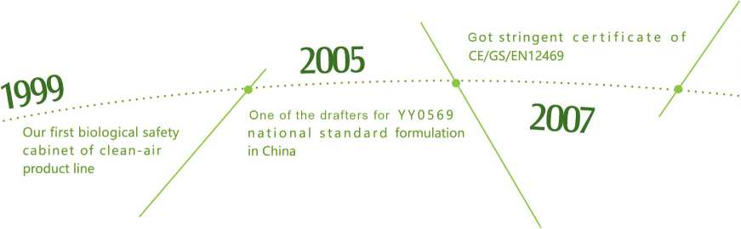

Proven reliability
Outstanding safety is assured through a variety of core components and features to improve cleanliness
Outstanding comfort
With several thoughtful features, from the view screen to the work environment and ergonomic design

What makes AlphaClean superior?

AlphaClean clean benches are ideal for a wide range of applications where sample protection is required.
Energy Efficiency
From the motor controller to lighting , the new design can provide significant annual costsavings while maintaining superior performance

Innovation makes cleanliness all possible Behind every great discovery there is the technology that made it all possible.
e
Laminar airflow over the working area takes containment to new levels, ensuring your safety
Smart and self-induced motor monitors and controls fan speed in real-time to maintain constant
airflow during filter loading and temporary obstruction
Flow-SaFe technology consumes less energy, reduces heat output and operates quietly

O Blower
Automatically compensates for normal power line variation, air diruptiona and filter loading. Motor consumes less energy, reduce heat output and operates more quietly.
Q Prefilter
Chemically and thermally enhanced technology increase filtration capacity and efficiency,together with ergonomical filter change design for easy maintenence
©Illumination lamp
Illumination provides sufficient brightness to the working chamber.
®UV lamp
Emission of 235.7 nanometers for efficient decontamination.
Automatic UV timer program saves your time during daily work
© Safety grade glass
The front glass window provides protection from explosion and UV with more comfortable viewing
Heal Force
©Friendly communication
Centered and angled down color-display for better at-a-glance viewing of safety and performance data.
<9Long life HEPA filter
Long life HEPA filter provides high separability for particles.
Self-compensation for the clogging of filters and life span indicator optimize working condition and minimizes services
O Real-time airflow monitoring
Velocity of airflow and temperature are inspected and indicated on control panel.Alert the user if airflow is insufficient
©Work tops
Standard constructed of seamless, non-porous type 304 stainless steel
O Universal electrical outlets
Two standard electrical duplex receptacles, with ground fault interruption and splash covers.
design, on-site validation,
customer support packages,
Maintenance is quicker and
easier than ever before.
Filter life indicator is designed to measure filter life span according to actual condition of membrane
Visual and acoustic alarm for indication of unsafe airflow conditions and window position
Interlocking safety mechanism is set between UV lamp and fluorescent light/front sash status.
The colored LCD display offers a high level of viewing and operation experience
i The intuitive interface delivers a constant read-out of working area temperature, air
J velocity/volume, filter life span, total running time
Easy-to-clean touchpad controls allow manual activation of blower, lamp, UV, electrical receptacles
and menu selection
AT
bT
c—\
抵 8888^88-88

8888.8, fl X 83-88-88 -8 B88.8 c * 国］嫁国圏国鳳
- Downflow speed/volume
- Filter working time
- Temperature
- Date or menu level
E.Time
- System status
- HEPA filter indicator
MUTE
ENTER
BLOWER
8
11.Fluorescent indicator
14.UV key
10.Blower key
- LCD display
- Mode/Return
- Turn on/off key
- Value change key
- Value change key
- Blower indicator
- Fluorescent key
- UV indicator
- Enter key
- Mute key
- Alarm indicator
11 10
14 13 12
H.HEPA filter lifespan
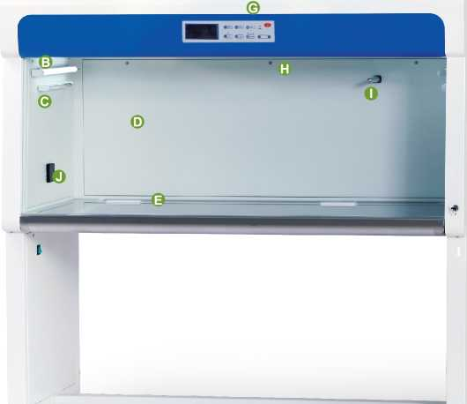
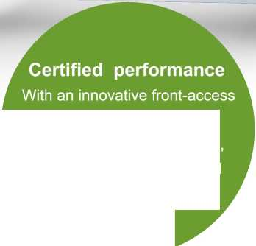
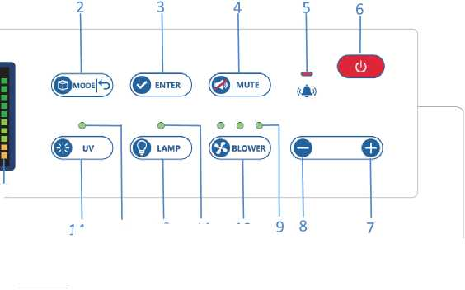

Enhanced comfort

and convenience

UV Decontamination
Knee
Clearance
5 ° backward-slanted safety grade glass provides protection from explosion and UV with more comfortable viewing than vertical sashes.
Counterbalanced sliding sash can be raised to a maximum height for easy introduction of large items
The position of the light tubes ensure excellent illumination over the whole working zone and reduces operator fatigue.
in this area
Silent working conditions save your brain, you can concentrate on work and even hear yourself thinking.
The radiused edge prevents the potentially dangerous practice of placing materials
Programmable automatic UV light timer simplifies operation while extending UV lamp life and saving energy.
Powerful UV irradiation illuminates entire work area, design to ensure thorough disinfection of the complete chamber
UV lamp with interlocking safety switch allowing operation only when blower and fluorescent light are off and sash is fully closed

Easy to Clean
The clean bench work zone has no welded joints to collect contaminants or rust.
Details of cabinet developed further to ensure easier cleaning with normal cleaning solvents
Airflow laminator protects the filter surface during wipe cleaning.
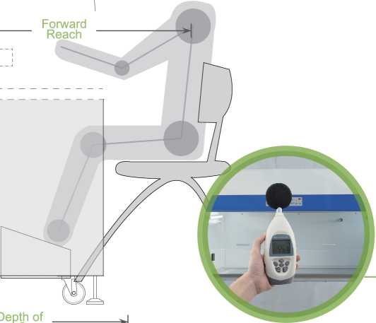
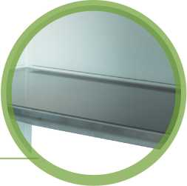
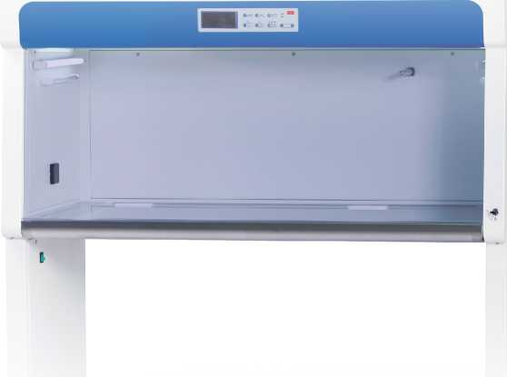

vice Access

& Validation

Standards & Test
Biosafety Cabinets | IEST-RP-CC002.2, Worldwide
Air Quality | ISO 14644.1, Class 5, worldwide
Filtration | EN-1822, Europe/ IEST-RP-CC001.3, Worldwide/ IEST-RP-007, Worldwide/ IEST-RP-CC034.1, Worldwide
Electrical Safety | EN61010-1, Europe/ IEC61010-1, Europe

Standards Compliance
Manufacturer Qualification ISO 13485:2003, ISO 9001:2008

Allservices, adjustments and filter change is carried out from the front of the cabinet.

Comprehensive performance testing
Every AlphaClean unit manufactured by Heal Force is individually tested, documented by serial number and validated with the following test methods.
Service Access
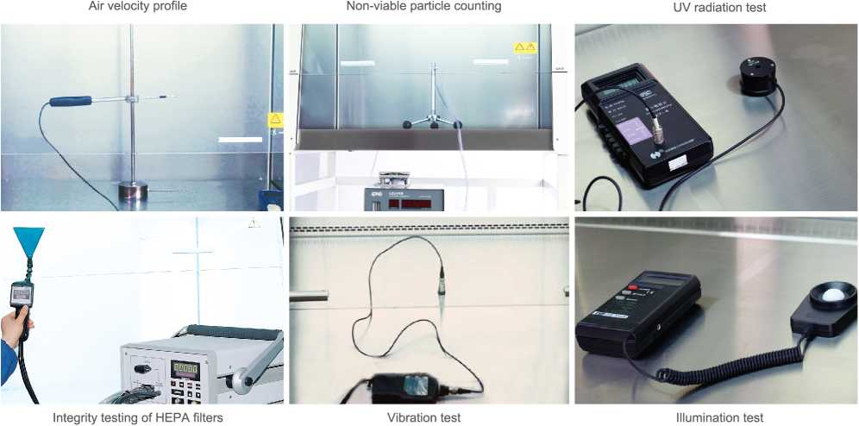
Air Velocity Profile | Verifies the hood is providing the proper air balance to protect the product from contamination
Integrity Testing of HEPA filters | Assures the existing HEPA filters are free of leaks and are properly sealed to prevent leakage or possible contamination to the work area
Non-Viable Particle Counting | Testing provided to verify clean bench is meeting designed air cleanliness classification level per ISO 14644 specifications
Viable / Microbial Air Testing | Assures Bioburden levels for bacteria and/or fungi are within acceptable parameters per the cabinet design or client specifications
Viable / Microbial Surface Testing | Assures Bioburden levels for bacteria and/or fungi are within acceptable parameters per cabinet design or client specifications
Airflow Visualization Profile | Verifies the hood is providing non-turbulent airflow to work area
Lighting Measurement | Verifies the lighting level is meeting the clean bench design level or worker comfort level
Sound Level Measurement | Verifies the sound level is not exceeding the clean bench design or worker comfort level

Temperature, Relative Humidity Measurements
Verifies the clean bench is operating within its design specifications
Help for certifiers, the maintenance assembly opens to a fixed position, providing front service access. Consequently, the cabinet can remain in situ without making any positional changes in your laboratory or having to disconnect any ducting.
All service is performed from the front of the cabinet, including:
Change of HEPA filters:
Fluorescent lamps
UV lamps
Adjustment or change of circuit boards and sensors
All adjustments to alarms, fan speeds, are made via the microprocessor control panel Service code protected
Validation
Heal Force offers a wide range of high quality services for all our equipment. These services include onsite validation, customer support packages, factory acceptance testing.
Choose Heal Force as an equipment supplier and validation consultant can greatly reduce the time and cost involved with getting new equipment compliant and ready for use.
Services Heal Force Offers:
On-site consultation
Unit specific authorized protocol documents
Customizable testing procedures to meet customer specific requirements
Unbiased testing of competitive equipment
Pre-delivery Services:
Validation support
Consultation
Factory acceptance testing
On-site Services:
Installation qualification Operational qualification
Calibration

AlphaClean Vertical Laminar Flow Clean Bench Engineering Drawing - Front, Side
General Specifications, AlphaClean Vertical Laminar Flow Clean Bench
- Pre-filter
- Blower
3.Supply HEPA filter
- Downflow sensor
- Counterbalanced block
- Water-proof electrical outlet
- Main power switch
- Adjustable Lever
- Universal Wheel
- Microprocessor control system
11 Fluorescent light
- UV light
- Toughened glass sliding door
14.Sash lock
15.Stainless steel single-piece work tray
I Model | AlphaClean 1300 I
Nominal Size | 1.3 meters
External Dimensions with Base Stand (WxDxH) | 1500x760x1630mm
Internal Work Area, Dimensions (WW^H) | 1380x650x510mm
Internal Workspace (Area) | 0.90M²(9.69 sq.ft)
HEPA filter size (WW^H) | 1320x580x50mm
Prefilter size (WW^H) | 400*380*3mm (2PCs)
Airflow
Vertical Velocity * | >0.3m/s(Adjustable)
Vertical Volume | m³/h (cfm)
Supply Filter
Type | HEPA
Material | Glass fibre fleece
Separability in MPPS | 99.995%
Separability at 0.3um particle size | 99.999%
Cleanliness in Work Area | ISO Class 5, Class 100 (Fed 209E)
No. of Sedimentated Bacteria Colony | <0.5CFU*0.5h
Sound Emission (Typical)* | <65dB
Fluorescent Light Intensity | 450Lux
Excellent light distribution | Yes
Fluorescent Light Power and Number | 11W,2PCs
UV Lamp Power and Number | 8W,2PCs
RMS | <5um
Cabinet Construction

AlphaClean Vertical Laminar Flow Clean Bench Engineering Drawing 一 Top
4
5
6
7
1.Pre-filter frame
2. Pre-filter
3.Mound layer
4.Upper cover
5.Pressure column
6.HEPA filter
/.Pressure block
Main Body | 1.2mm(0.05") steel with white oven-baked epoxy-polyester power-coated
Side Walls | 1.2mm(0.05") steel with white oven-baked epoxy-polyester power-coated
Work Zone | 1.5mm (0.06") stainless steel, grade 304
Window Material | Hardened/laminated safety glass
Working Temperature | 10 〜30 C
Working Humidity | 30 〜75%RH
Electrical (220-240V, 50/60Hz, 1 phase)
Cabinet Full Load Amp(FLA) | 2.5A
Optional Outlets FLA | 3A
Cabinet Maximum Power | 550VA
Cabinet Nominal Power | 300VA
Power Supply**
220V±10%/50Hz | Yes
220V±10%/60Hz | Yes
110V±10%/60Hz | Yes
Protection
Protection class I
Protection type | IP20
Overvoltage category | II
Contamination degree | 2
Net Weight | 185kg(408lbs)
Shipping Weight | 250KG
Shipping Dimensions Maximum(W^D^H) | 1600*840*1800mm
Shipping Volume, Maximum

Specification are subject to change without notice * at initial setpoint with uniformity of better than +/-20% ** Please contact us for more optional power supply information
